INITIAL DEMOLITION NOTICE

Section 138A and Schedule 5A of the Housing Act 1985
as amended (“the Act”)

NOTICE IS HEREBY GIVEN that the London Borough of Barnet (“the Council”) intends to demolish the following properties (“the Relevant Premises”), comprising part of the Grahame Park Estate, NW9 (“the Estate”):

- 1-22 Slatter
- 1-6 Spooner
- 1-16 Sopwith
- 1-12 Spitfire
- 1-22 Tait
- 1-24 Tedder
- 1-24 Wheeler
- 1-12 Whittaker
- 1-12 Whittle
- 1-6 Wilshire

Reason for Demolition

The demolition of the Relevant Premises is necessary in order to enable the completion of Phase 1 of the Grahame Park North East regeneration scheme to provide new affordable and private homes, together with the provision of community facilities.

Demolition Period

The Council intends to demolish the Relevant Properties by 10th July 2032 that date being not later than 7 years from the date Notice is first served on tenants.

This Notice will remain in force up to and including 10th July 2032 unless revoked or otherwise terminated under or by virtue of paragraph 3 of Schedule 5A of the Act.

Effect of this Notice

Whilst this Notice remains in force the Council will not be under any obligation to make such grant as is mentioned in section 138(1) of the Act in respect of any claim to exercise the Right to Buy in respect of any of the Relevant Premises.

This Notice does not prevent:-

- tenants from making a claim to exercise the Right to Buy in respect of the Relevant Premises;
- tenants from taking steps pursuant to Part V of the Act in connection with any such claim up to the point when section 138(1) of the Act would otherwise apply
- the operation of section 138(1) of the Act in most circumstances when this Notice ceases to be in force,

BUT if the Council subsequently serves a Final Demolition Notice in respect of the Relevant Premises, the Right to Buy will not arise in respect of the Relevant Premises while that Notice is in force and any existing claim will cease to be effective.

Right to Compensation
- If, at the time when this Notice is served, you have an existing claim to exercise the Right to Buy in respect of a property you may have a right to compensation* under section 138C of the Act;
- Written notice of any claim for compensation must be served on the Council within three months beginning from the Operative Date* of this Notice;
- A claim for compensation must state the amount claimed and must be accompanied by receipts or other documents showing that the expenditure in question was incurred.

*Compensation is in respect of expenditure reasonably incurred by a tenant before the Operative Date in respect of legal and other fees, and other professional costs and expenses, payable in connection with the exercise of that Right to Buy claim.

*The Operative Date of this Notice is 10th July 2025 that being the date a copy of this Notice was served on the tenants of the Relevant Premises.

Dated this 10th July 2025

Signed: 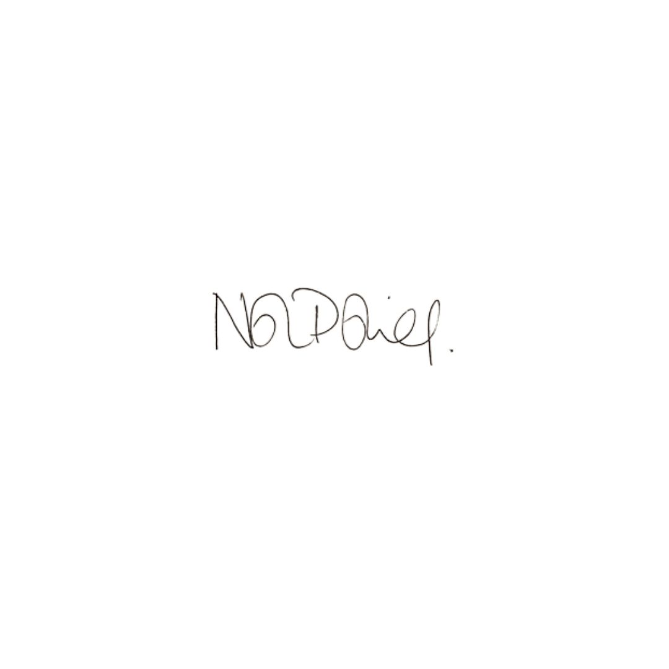

Naisha Polaine
Executive Director of Growth
For and on behalf of Barnet Council

