GET  SUPPORT

FACTS AND FIGURES
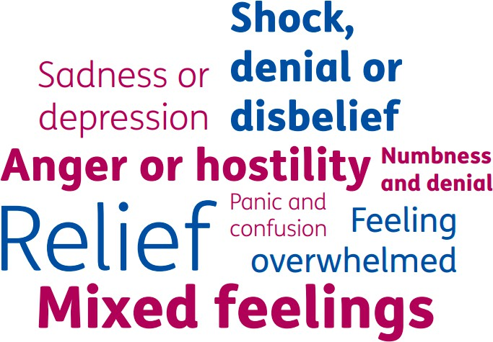
7%
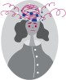
of people who are bereaved go on to develop
“complicated grief”

Up to 135
people are affected to some degree by every person lost to suicide

HELP AND ADVICE
- Most people experience grief when they lose someone important to them. It affects everyone differently. There's no right or wrong way to feel.
- Sudden bereavement can bring about feelings of shock, disbelief, and difficulty accepting the loss of a loved one.
- These emotions may be further intensified by any uncertainty or change felt which can lead to feelings of isolation. Talk about your feelings to a friend, family member, health professional or counsellor – you could also contact a bereavement support organisation. Many people find it helpful to reach out and talk to someone about their feelings, others may wish to deal with the loss in private.
- Some people may need additional and more specialised support to help to cope with a bereavement.
- Try not to focus on the things you cannot change – focus your time and energy into helping yourself feel better.
- Try not to use alcohol, cigarettes, gambling or drugs to relieve grief – these can all contribute to poor mental health.

GET SUPPORT
LOCAL SERVICES AND ONLINE SUPPORT

Service | Type | Description | Details
Cruse Bereavement Care | - Phone  - Email | Trained volunteers offer confidential face-to-face, telephone, email and website support, with both national and local services. | Phone: 0808 808 1677  Email: helpline@cruse.org.uk  Website: www.cruse.org.uk
Survivors of Bereavement | - Phone  - Email | Survivors of Bereavement by Suicide (SOBS) offer support for those bereaved or affected by suicide. | Phone: 0300 111 5065  Email: email.support@uksobs.org  Website: https://uksobs.com/
Barnet Bereavement Service | - Face –  to-face  - Online  - Phone | This organisation offers skilled counselling support to people who have been bereaved.  Counselling is offered one hour per week either in the person's home or at the office. There is no charge for the service. | Email: info@barnetbereavementservice.o rg.uk  Phone: 020 8368 8880
Grief Encounter | - Online  - Phone | A service which provides information, guidance and support to bereaved children and their carers following a bereavement. | Email:  grieftalk@griefencounter.org.uk  Phone: 020 8371 8455  Website:  www.griefencounter.org.uk  Helpline: 0808 802 0111
Barnet mental health and wellbeing services | - Online | Barnet Council has a dedicated webpage listing a range of mental health and wellbeing services and support available both locally and online. | Website: www.barnet.gov.uk/mental- health-and-wellbeing

