**Barnet Youth Assembly**

**Are you interested in local politics or want to build up your CV for next steps in education or work?**

Young people under 18 cannot vote or stand for election. But you can still get involved by joining Barnet Youth Assembly!

We meet at Hendon Town Hall 6 times a year, on a Tuesday evening and sit in the council chamber, which is normally only used adult elected politicians.

At these assemblies young people debate and vote on motions - these can be about anything of interest or importance to young people that relates to Barnet.

Local councillors and senior council leaders often attend these meetings to listen to the views of young people. There is a chance to network between young people and locally elected politicians so you can share your ideas with them directly. You will get the chance to build your skills in public speaking and campaigning on local issues.

Youth Assembly is chaired by 3 elected young people and members meet online between assemblies to select the motions to be debated.

If a motion passes we offer to support the young person to lobby to get their motion acted on. The harder you campaign the more chance you will be able to influence things! We will help you develop the skills you need! You can still attend and take part even if you don’t want to propose a motion – Youth Assembly is a great way to meet others with similar interests and build skills for further education and the workplace.

Anyone in year 7-13 (aged 11-18 years) who lives or studies in Barnet can join and you don’t need to be elected but you do need to fill in an application which takes 5 mins here:

or speak with [Rebecca.Morris@barnet.gov.uk](mailto:Rebecca.Morris@barnet.gov.uk) - she can also tell you about the process to become a chair.

**We welcome young people from all backgrounds and Barnet communities. If you need adjustments to attend please get in touch. The Town Hall is an accessible venue with a ramp, lift and hearing loop. If you need prayer facilities let us know.**

**Barnet Youth Board**

**Do you want to shape Barnet services or build experience that may help with your next steps in education or work?**

At Youth Board council staff meet with young people to ask you for advice and feedback about plans to improve Barnet for residents.

Barnet Youth Board meets at the Council head office in Colindale on a Thursday evening once a month. It is chaired by two young people – Barnet’s elected Youth Ambassadors.

As part of the Barnet’s My Say Matters approach we want to make sure all plans and services are developed with our residents.

We want to consult young people by asking your opinions but also go further than this by co-producing the plans we make with you. This means you may get a chance to see some of your ideas in the plans and be part of the process from the beginning to the end. You will also get the chance to learn about the ways different council departments works and gain valuable insight into the work place. You can build skills you may need on your education or career path.

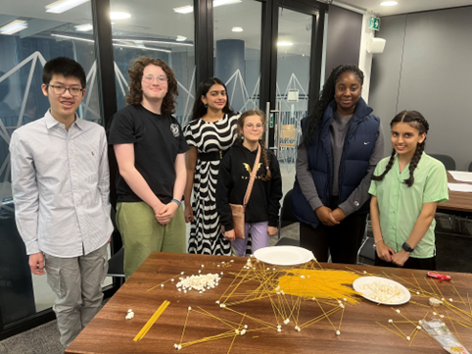

In 2023- 2024 Youth Board contributed to the following

* Barnet Children and Young Peoples Plan
* Towards a Fairer Barnet Policy – the councils Equality Diversity and Inclusion Policy
* Sustainability and transport strategies
* Health Improvement – school food and mental health services for young people
* Tackling Child Exploitation strategy

The meetings are fun, friendly and informal. We usually have 2 guests who will lead an activity to tell you more about the project they are working on and the questions they have for young people and ways they want you to give your ideas.

Anyone in year 7-13 (aged 11-18 years) who lives or studies in Barnet can join and you don’t need to be elected but you do need to fill in an application which takes 5 mins here:

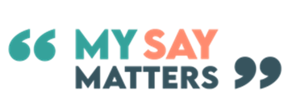

or speak with [Rebecca.Morris@barnet.gov.uk](mailto:Rebecca.Morris@barnet.gov.uk)

**We welcome young people from all backgrounds and Barnet communities. If you need adjustments to attend please get in touch. Our Colindale office is an accessible venue with a lift and hearing loop.**