Timber framed houses
Survey Guide – Pre Inspection
The inspection process will be looking for any likely ignition sources and checking that in the event of a fire you and your household will have the best opportunity to escape unharmed.

This guide aims to provide important information in advance of what surveyors’ will be looking for, and examples of what is considered to be good mitigation and best practise to reduce the ignition risk.

Property.
- The Council are making improvements to the external timber cladding to all council owned houses to prevent the risk of external spread of flames across houses.
- If your house is positioned between two council houses in a terrace, at the end of a terrace or in a pair of semi-detached houses neighbouring a council owned house, the risk of external spread of flames will be removed due to the works undertaken to the Council owned houses.
- The Council still wish to inspect your house to check for other ignition risks and will require you to sign a party wall agreement, to enable the council to complete the remediation works on your neighbours property.
Smoke alarms.
- Smoke alarms are probably the single most important fire safety measure you can have in your home. Ideally smoke alarms that are electrically powered and interlinked, that all sound at the same time are the best option.
- Sufficient numbers of battery-operated alarms may give you and your family adequate early warning provided you can hear the alarm sounding from the ground floor into the farthest part of all the bedrooms. If you are relying on a non-linked smoke alarm on the landing to warn you of smoke, it will already have spread in the house which will reduce the amount of time you have to escape.
- If sufficient working smoke alarms are installed in your house the overall fire risk will be reduced

Electrical installation.
- The primary sources of ignition arise from electrical installation and careless use of chargers and appliances.
- Consumer units that have overload protection as part of the unit (mini circuit breakers (MCB) and residual current devices (RCD)) will reduce the risk of an overloaded installation leading to fire.
- Metal fire resistant electrical consumer units are considered to provide the best safety, which are installed in all new domestic buildings.
- If you have an electrical consumer unt in your house the risk of overloading and a resulting fire is reduced

Metal consumer unit
- Metal consumer unit are considered as good mitigation against electrical overloading and possible electrical fire.

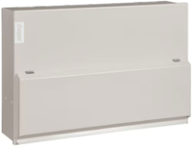
Plastic consumer unit
- Plastic consumer units are older than metal fire resistant units, and may present a risk of fire, especially if the components fail or overheat. They are often placed enclosed spaces for example cupboards or under stairs, where ventilation is limited, increasing the risk of rapid fire spread.
- The Surveyor will note what type you have, the Council will not be requiring you to replace a plastic consumer unit, however, may recommend replacement as recommended best practise.
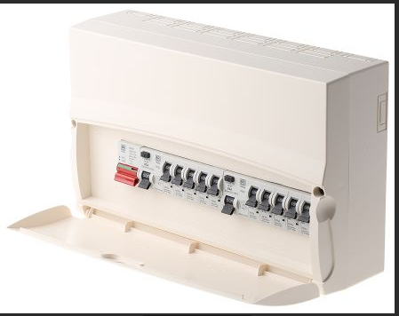

Older consumer units.
- These may have cartridge or rewireable fuses with no RCD protection, older wiring and fewer plug sockets in the house. Due to the increased likelihood of fire it is recommend that the electrical installation is thoroughly checked for electrical safety by a competent person .
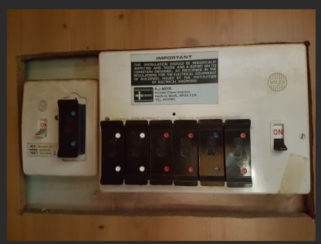
Cartridge fuses

Plug socket outlets
- Having sufficient plug sockets in your house is an important fire risk control measure. According to the electrical safety first document Minimum provision of electrical Socket-outlets in the home.

“The increased use of home electronics and entertainment systems has led to the situation where, not only are homeowners using extension leads for their TV and associated media but also for many other locations in their homes

Not having sufficient socket-outlets may lead to risks such as:
• DIY extensions to circuits undertaken safely if the work is carried out by unskilled persons
• DIY extension to equipment flexes
• Cascading (daisy chaining) of extension leads
• Stacking of adaptor plugs

All of the above will create potential hazards, such as risk of tripping over leads, electric shock or injury and damage to property through fire.

- Electrical plug socket-outlets should be suitably distributed around rooms, due account being taken of furniture, electrical equipment and future change of use. Guidance for the provision of sockets can be downloaded from electrical safety first website. https://www.electricalsafetyfirst.org.uk/media/1204/guidance-on-minimum-provision-socketsv2.pdf

- If there are insufficient plug sockets there is an increased risk of overloading plug socket outlets. The electrical safety first socket calculator should be referred to when assessing for potential overloaded extension socket boards https://www.electricalsafetyfirst.org.uk/guidance/safety-around-the-home/overloading-sockets/

The Surveyor will try to count the number of plug sockets in all rooms without moving any furniture. If any risk of overloading or burnt-out plug sockets is identified, you will be advised in writing.

Downlighters
- Poorly installed halogen ceiling downlighters can present a fire risk due to the heat they generate, which could possibly be in an enclosed cavity. If halogen downlighters are in contact with flammable materials, there is an increased ignition risk in the ceiling void. You may not notice smoke and fire seeping through a floor/ceiling void until the fire was well developed.

The Surveyor will not unclip recessed downlighters to check for fire rated caps, however will seek to identify if they are LED or halogen.
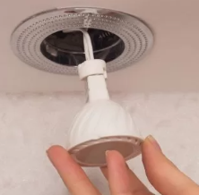

Means of escape windows.
We will be checking for adequate emergency means of escape windows from the first-floor bedrooms.
- If your house has escape windows you may wish to check if you think you can safely escape from the first floor.

House heating system.
- Full house boiler central heating systems supplying radiators are ideal to minimise heating system fires.

- Open solid fuel fires, portable fan and convector heaters can increase the fire risk especially if the portable heaters are left on for extended periods and sited too close to combustible items such as clothes drying on a clothes horse, curtains or bedding etc.

- If you need secondary portable room heaters, thermostatically controlled oil filled heaters with a time clock are safer as there is very little likelihood of careless ignition. The heaters are unlikely to reach a sufficiently high temperature on direct contact with clothes bedding or curtains so as to result in fire

Internal doors.
- Closed internal doors are important in preventing the spread of smoke in the early stages of a fire and flames in a more developed fire.
- The thicker and more solid the door, the longer a closed door will hold back smoke and flames from spreading in a house. Lightweight egg box doors offer very little fire resistance. The Surveyor would recommend that these types of doors are replaced with a solid core door.

Conclusion
In conclusion if you have these elements in your house the fire risk will be reduced, keeping you and your household safe.
- Smoke alarms that are ideally linked together.
- Fire resistant electrical consumer unit.
- At least 3 double outlets in the bedrooms (depending on size) and ideally at least 4 double outlets in the kitchen and living room.
- If you have ceiling recessed downlighters that these are LED.
- No portable fan or convector heaters in the house.
The Council are keen to arrange to inspect you home to check you are safe and to offer any advice to reduce any risk further if possible.

Occupier checklist

Smoke alarms | Interlinked electrically powered | Separate battery operated | None
Electrical consumer unit | Metal with MCD and RCD | Plastic with MCD and RCD | Cartridge fuses
Number of plug double socket outlets | Kitchen | Living room | Bedroom  Bedroom  Bedroom
Downlighters | Halogen | LED | None
Portable heaters | Convector | Fan | Oil or none

