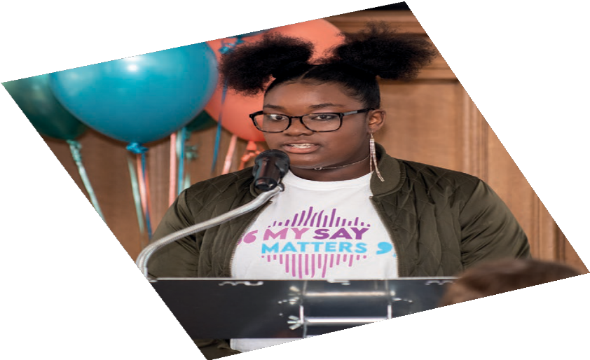
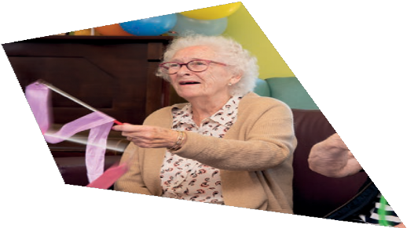
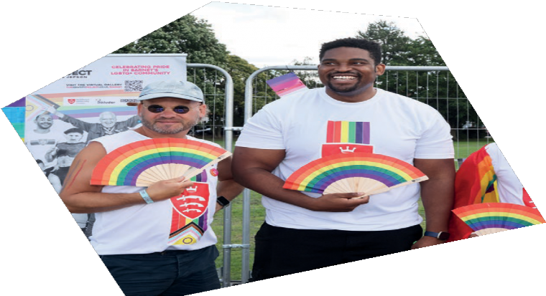
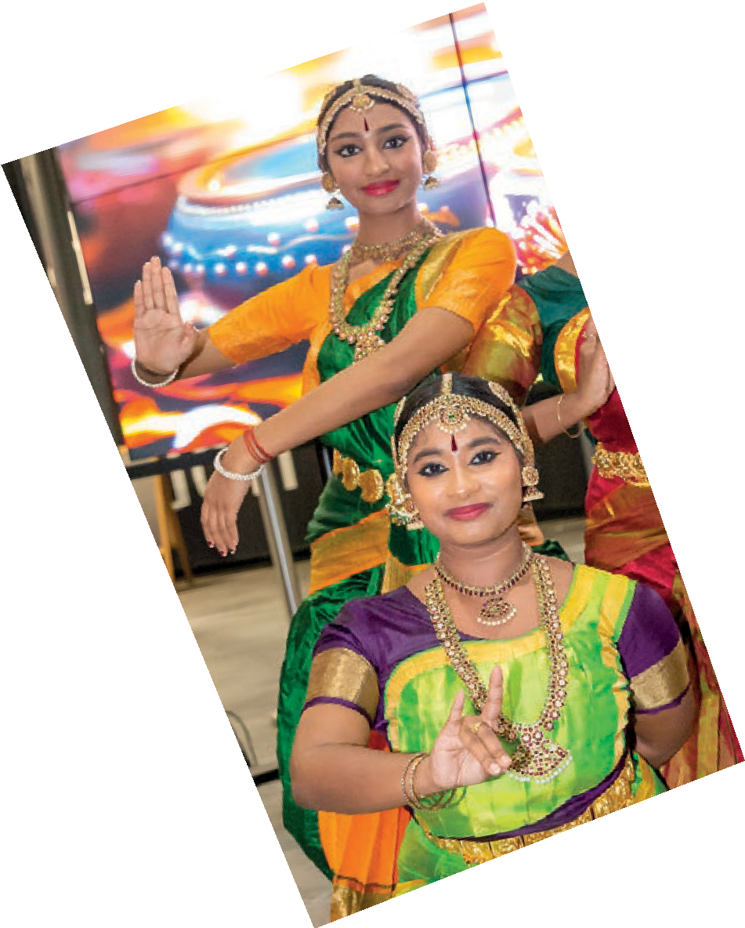




Towards a Fair Barnet
Our roadmap to create a more equal Barnet, where local people can belong
2024-2030

Caring for people, our places and the planet

www.barnet.gov.uk
Towards a Fair Barnet 2024-2030 1
Our roadmap to create a more equal Barnet, where local people can belong
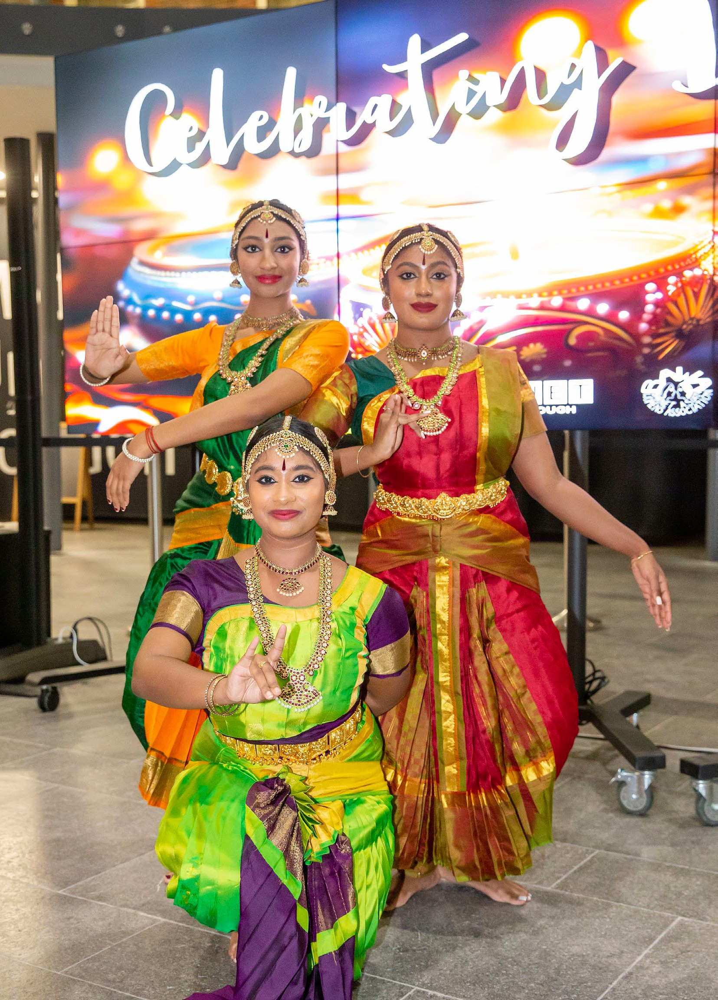
Caring for people, our places and the planet

To celebrate Diwali in 2023, Barnet Council hosted an event in collaboration with Barnet Asian Woman’s Association (BAWA) at Middlesex University

Towards a Fair Barnet 2024-2030
2
Our roadmap to create a more equal Barnet, where local people can belong
Foreword
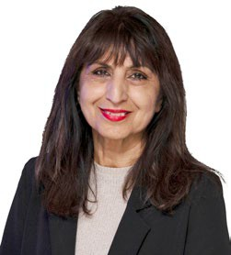
Challenging inequality is a key priority for the council. This work is as much about addressing the barriers stopping people from accessing opportunities today as it is about long-term

Cllr Zahra Beg
Cabinet Member for Equalities, Voluntary and Community Sector

Barnet is London’s second most populated borough, full of character and rich communities celebrating heritage from all over the world. Our residents, businesses and visitors love the borough’s green spaces, fantastic transport links and our outstanding
schools. Our residents tell us that they get on well with their neighbours and that families feel safe calling Barnet home.
Yet despite these strengths, far too many people are not able to benefit from the best of this borough, with the gap in inequalities widening between those able to access and gain from opportunities, and those who cannot.
Our vision of a borough where life chances are improved so that everyone can lead a good, healthy, happy and long life can only be realised by tackling the inequalities that hold back our communities.
impacts on levelling the playing field in all areas of life, including housing, health, education and work opportunities.
So much of the success rests on how well we understand our residents, both from what they tell us of their experiences as well as what
we know from data and intelligence on the unequal probabilities of outcomes for people with different characteristics.
Our ‘State of the Borough’ report, produced as an evidence base for this roadmap, is the first of its kind for this council and shows us the inequalities being experienced in Barnet.
It recognises that people live multifaceted lives and that no one is defined by one identity.
We have been considering how multiple characteristics interact to deepen inequalities experienced.
We are a council that is committed to listening to our residents and this will continue to inform how we tackle inequalities. Narrowing the gaps between our residents is an objective for all of us and we will work industriously with our partners and communities to create a fairer Barnet.

Introduction
Barnet is a rich tapestry of different cultures and life experiences. The people who live, work and grow here come from all walks of life and from all over the world. When they meet to share their experiences, learn from one another and celebrate differences with mutual respect, we see the very best of this borough. We are proud to be home to diverse communities and we want Barnet to be a place where every resident feels they belong.
Barnet’s 389,000 population is made up of a multitude of well-established communities, each with its own unique identity and contribution to the borough’s culture. This includes some of the highest numbers of people who have cited their faith in the UK 2021 Census – a key part of understanding our diverse communities and their experiences.
We celebrate this throughout the year,

bringing communities together in events and festivities. These have included Black History Month, International Women’s Day, Lighting the Menorah, Big Iftar, Barnet Pride in the Park, Refugee Week and South Asian Heritage Month.
Whilst we recognise that Barnet’s diversity is one of our greatest strengths, we know that not everyone’s experience of Barnet is the same, with some finding it easier
to access services and take advantage of opportunities than others. Some people face structural discrimination when institutional and other common practices within society disadvantage them across many aspects of their lives. Others face disadvantage and social exclusion because of low income and poverty.
People experiencing discrimination have lower levels of power to effect change in their circumstances.

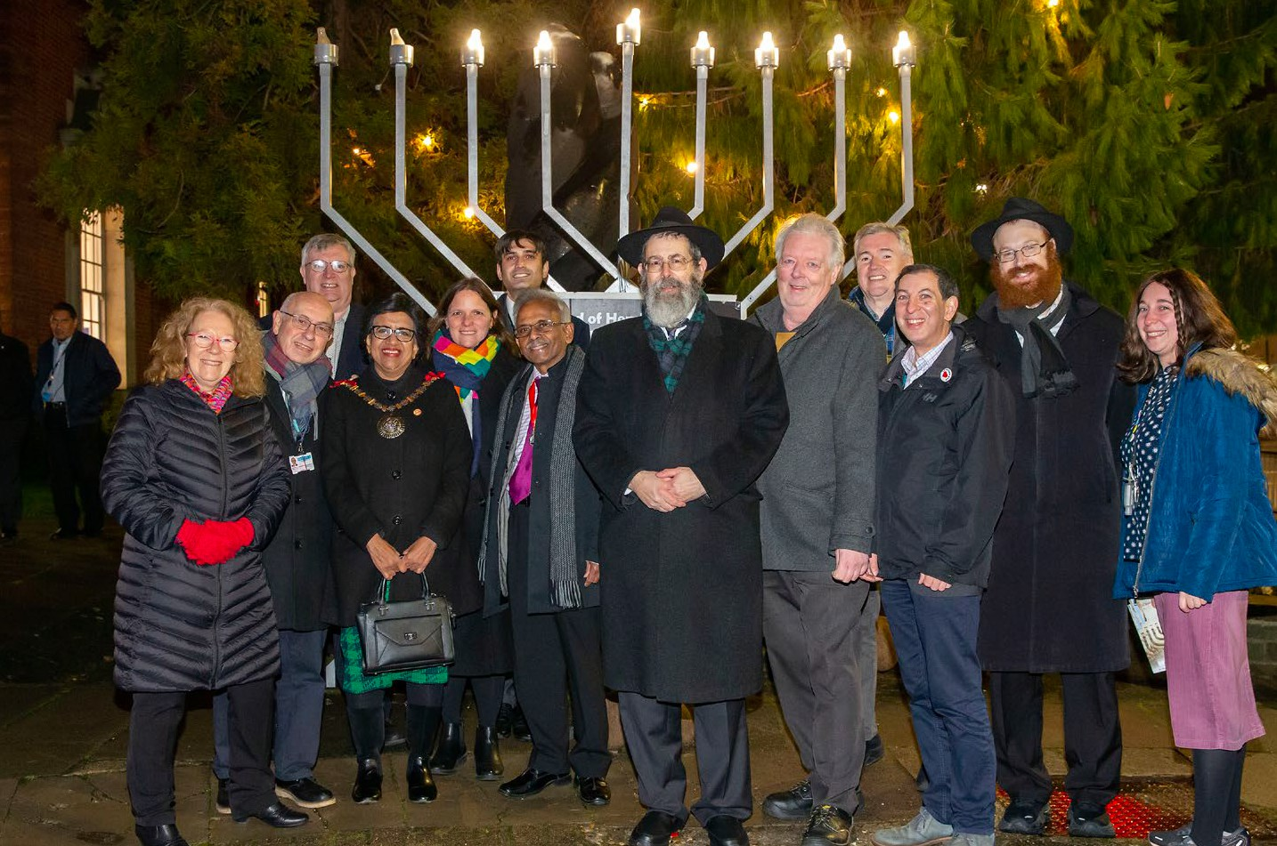
At Hendon Town Hall, Jewish residents, the leader of the council, and the mayor of Barnet, come together to celebrate Chanukah with a menorah lighting

Equity
This fairness roadmap aims for equity, not just equality of access. By this, we mean that some groups need more support than others to reach similar outcomes and we know
that multiple characteristics can combine to increase inequalities and disadvantage. We will adapt our interventions according to the needs of our communities.

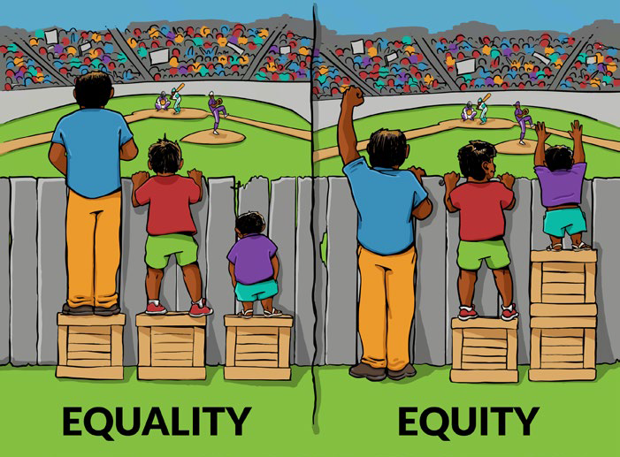
Equality would give all spectators the same height box to stand on, even though the shortest spectator needs a much taller box. Equity gives all spectators the right height of box they need to see over the fence

Our vision

In launching this roadmap, we aspire to:
“A future in Barnet where the communities and places you belong to never unfairly impact the quality of your life and where accessible and efficient public services support the wellbeing of all residents.”
We know there is more we need to do to ensure that we treat people according to their individual needs and circumstances.
We will tackle inequalities by actively listening to and considering different perspectives and needs in policy making and service design. We will reach out and listen to every part of our diverse community as we know they have the experience, skills and insight to help us work towards meeting our ambitions and improving their lives.
Our vision is informed by the priorities in ‘Our Plan for Barnet 2023-2026’ for tackling
inequalities and fighting poverty which affect everything from health and education to work opportunities:
- Fight inequalities and work to improve life chances for a good, healthy, happy and long life. Working in partnership, we will ensure no one is held back, that Barnet is the healthiest borough in London and our communities and residents can take advantage of every opportunity.
- Reduce poverty in our communities, boosting incomes and reducing costs. We will create an inclusive Barnet by promoting long-term economic growth that benefits everyone and where families and communities support each other.
- Be a family friendly borough where children and young people have the best start in life with the best education, the right support and safeguarding when they need it, and the right tools to live their lives successfully into adulthood. This especially applies to our children in care and care leavers, for who we are ‘corporate parents’.
- Focus on all residents having the best opportunities to live well and feel part of the community. This will mean increasing the inclusion of older and disabled residents and celebrating their contributions. We
will recognise people’s goals and support them to build on their existing abilities and strengths. We will work with residents, communities and our partners to support residents to stay well and free from abuse.

Tackling the gaps: fighting inequalities
The challenges we face today are numerous, with some localised in our borough and others entrenched across the city and country. A full breakdown of known inequalities being experienced in Barnet has been produced in the ‘State of the Borough Report 2023’, which will be updated annually.

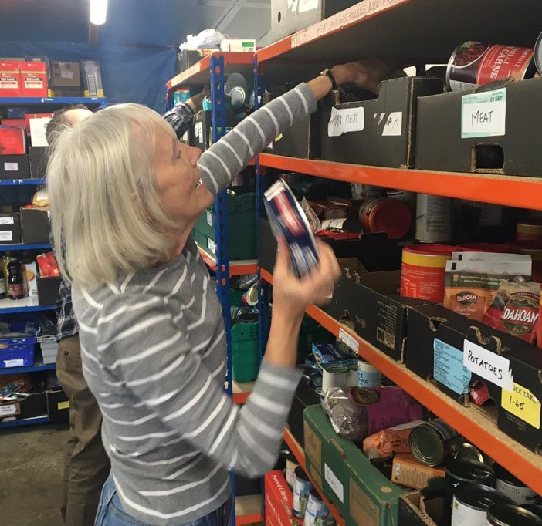
Health inequalities
Food banks support residents struggling with the cost of living crisis in Barnet
Where you live and grow up can affect the length and quality of your life. If you live in the most deprived areas of the borough, you are likely to live 6.7 years less if you are a man, and 5.7 years less if you are a woman, than your neighbours in the most affluent wards.
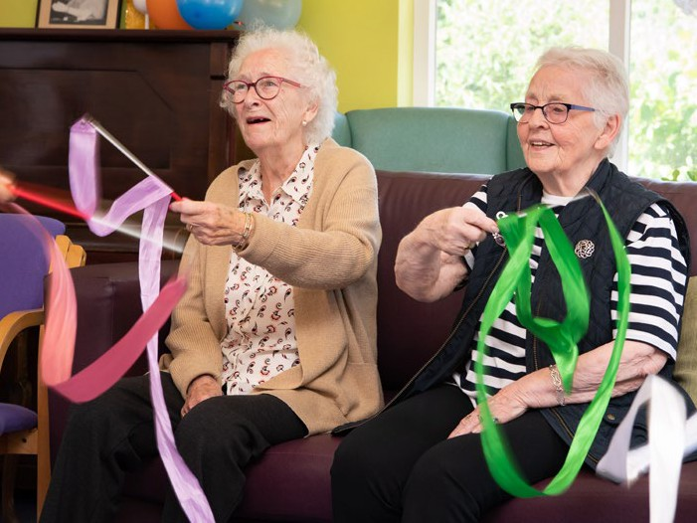
Over the last decade, that gap has been on a narrowing trajectory for men, but worryingly, has only increased for women. Circulatory and respiratory conditions and cancer are significant contributors to these gaps.
Adult social care aims to provide Barnet residents with the support they need

Cost of living
This roadmap is being launched at a time when the cost of living in the UK increased sharply and inflation remains higher than pre- 2021 levels. Prolonged high inflation increased food, energy and fuel prices and has affected different types of households at varying levels. Low-income households are more impacted by high food prices, disabled people are more likely to be affected by high energy costs and renting in London’s private sector is becoming unaffordable for people in receipt of benefits and low incomes. Women are increasingly locked out of the economy by increasing childcare costs and maternity pay that has not risen with inflation.

Health inequalities are often related to people’s education, homes, employment and environment, not just their individual lifestyles. For example, an environmental factor that affects our health is air pollution
and people’s exposure to this is unequal across Barnet. There are higher levels of air pollution

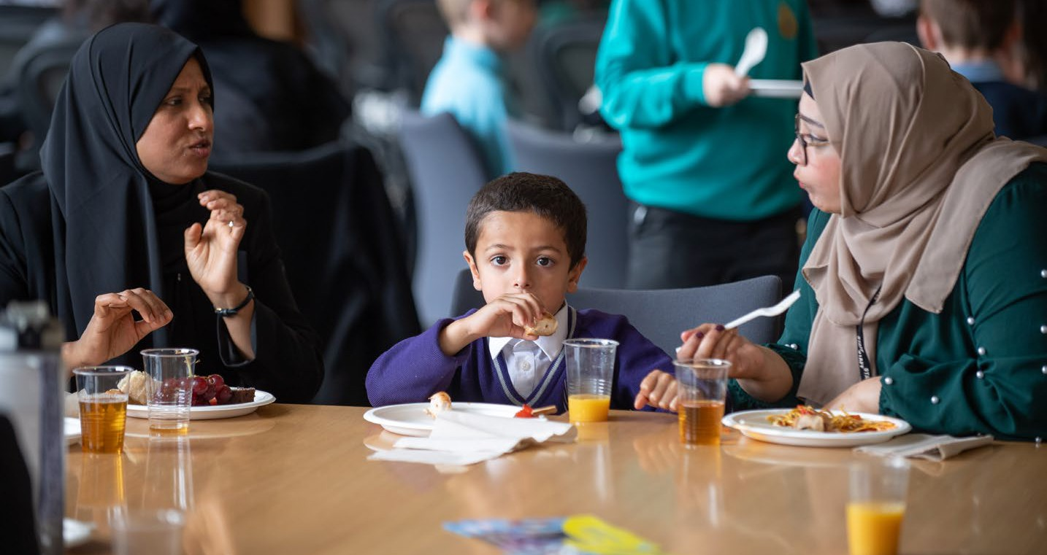
Barnet schools are proud to participate in Healthy Schools London and Healthy Early Years programmes which support healthy eating and exercise in schools

in more deprived parts of the borough and along main roads. Disproportionate negative impacts like this one are what this roadmap seeks to tackle by considering the root causes of the inequality and adapting policies and interventions to stop the gaps from increasing and aiming to close them.

Earning gaps
Across London, there are earnings gaps causing ripples of deep inequality, starting from income distribution through to all other areas of life. The disability pay gap is at 16.6%, Black workers are paid a median hourly wage 19% lower than the average White worker and the figure is 10% lower for Asian workers.
Men in Barnet earn 10% more on average than women and are twice as likely to be managers, directors or senior officials.

Growing up
Inequalities often start to take root from early ages where we see multiple disadvantages impacting life chances. Children receiving free school meals perform less well at GCSEs and we know that Black students and students from other ethnic groups are three times more
likely to receive free school meals.
Children who grow up in poverty are likely to suffer poorer education and health outcomes throughout their lives. In Barnet, there are pockets of high deprivation affecting children in Burnt Oak (22.4%) and Colindale (19.2%), which are above the London rate (16.4%).
More than one-third of working age residents with disabilities are
economically inactive
• White employees earn 19% more on average than Black workers across London
• More than one-third of working age
Black residents are economically inactive
• Men earn 10% more than women on
average in Barnet

Excerpt from State of the Borough 2023 report
• Disabled employees earn 17% less than
non-disabled employees in London
• Men are twice as likely to be managers,
directors, or senior officials
• Residents from ethnic minorities born in the
UK have the highest unemployment rate
Beyond the statutory duty

We are committed to meeting the legal requirements of the Equality Act 2010 and the public sector equality duty, but we want to go beyond this to do more to create a fairer Barnet.

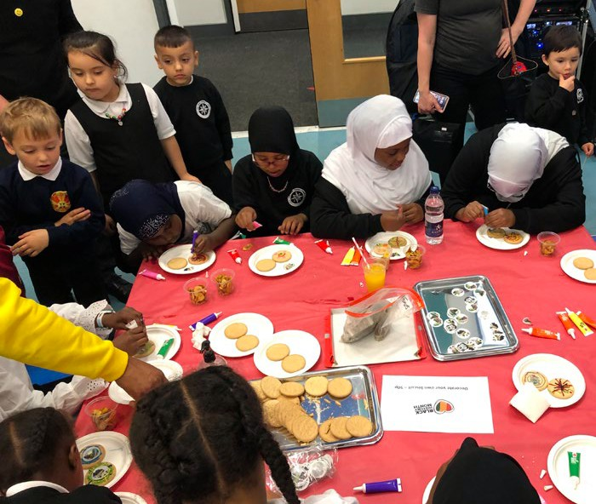
This roadmap sets out our external, community-focussed equality objectives for 2024 - 2030. These have been informed using information about inequalities in Barnet drawn together in the ‘State of the Borough Report 2023’, the results of the ‘Residents’ Perception Survey 2022’ and by the views expressed
Primary school children have a snack break in the classroom
by residents through our community engagement.

Building a Fairer City

We have also considered ‘The Building a Fairer City‘ plan produced by the London Recovery Board, which outlines actions under four priority areas:
- Labour market inequality
- Financial hardship and living standards
- Equity in public services (tackling structural discrimination)
- Civic society strength

Supporting our care experienced young people
In addition to the nine protected characteristics, we recognise that care leavers face significant barriers that impact them throughout their lives and that their needs are often not considered in decisions that affect them. The council has become a signatory to the Care Leavers Covenant going beyond our statutory duties to include care experienced people at the heart of decision-making through co-production and collaboration.

There are around 500 looked-after children in Barnet (based on 2023 data) and within this group, there is disproportionate representation of minority groups. Black boys are 3.2 times more likely to be included in this group
than White boys. Boys from other ethnic groups (2.6) and a mixed or multiple ethnic background (2.2) are also over-represented. Black girls are 2.7 more likely to be looked- after, followed by those from a mixed or multiple ethnic background (2.0) and other ethnic groups (1.4).
As they are more likely to face discrimination and multiple disadvantages, we will lobby government for a change in the law to allow care experience to become a protected characteristic under the Equality Act and other legislation. To build on the decision to adopt the Care Leavers Covenant, we have made meeting the needs of people with care experience a priority in this roadmap.

Addressing inequality through Community Wealth Building
Our community wealth building approach addresses financial hardship, living standards and labour market inequality, much of which is achieved through partnerships in civic society. It is based on the five principles of community wealth building:
- Plural ownership of the economy
- Making financial power work for local places
- Fair employment and just labour markets
- Progressive procurement of goods and services
- Socially productive use of land and property
Our business support programme focuses on helping small enterprises as they are more likely to employ, buy and invest locally and lock wealth in Barnet. We support these enterprises by running business support schemes to help companies grow and develop the knowledge and skills of their staff. We provide them with access to free expert business advice. We will consider how we
can support cooperatives as part of our new economic development framework.
We continue to expand the impact of our innovative benefits calculator, our employment and skills support through
BOOST and considering what debt advice we may be able to provide. We will engage local businesses to encourage them to pay fair wages to reduce in-work poverty and promote adoption of the Mayor of London’s Good Work Standard to improve the working lives of residents.

Our social value policy delivers socio- economic benefits that support our priorities to reduce poverty, tackle inequalities and build community wealth. It ensures that our supply chain has a positive impact on our communities by maximising the benefits of our contracts and investments. The policy
ensures that people who live in Barnet are the ones to benefit from supplier social value
commitments. We will consider how our Social Value Impact Fund can be used to support the delivery of our new equalities objectives.
In many of the areas covered by this roadmap, we work with our partners in civic society, benefitting from their strengths and assets to reach diverse communities, targeting initiatives to those most impacted by inequality. We also have public sector partners like the police and NHS who we will work closely with to support their own plans for addressing discrimination.
We will consider how our commissioning, investments, assets, grants and other activities can be used to strengthen civic society to support us in meeting our commitments on tackling inequalities.
The proposed new approach to tackling inequalities in this roadmap aims to tackle structural discrimination to ensure equity in public services.
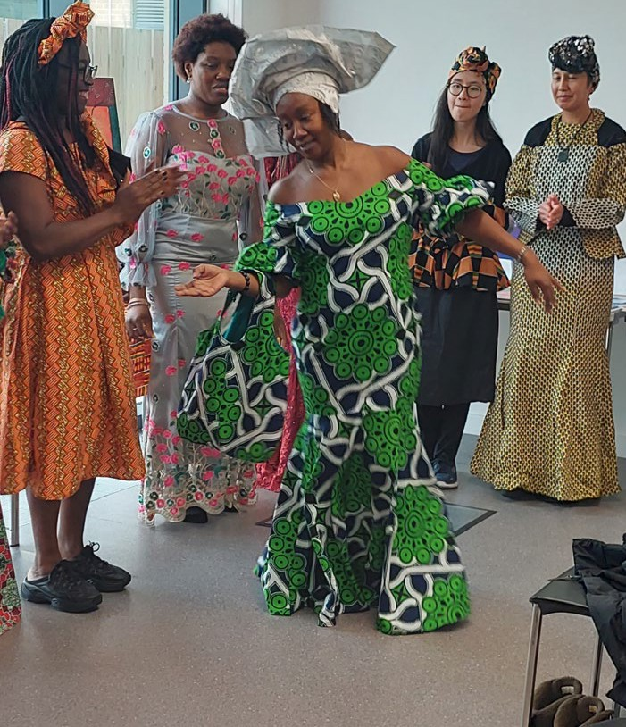
Black History Month celebrations take place every year across the borough

Meeting our legal obligations
For all protected characteristics1 , we will have regard to the need to:
- eliminate unlawful discrimination, harassment and victimisation and any other conduct that is prohibited by or under the Equality Act 2010;
- advance equality of opportunity between people who share a relevant protected characteristic and people who do not; and
- foster good relations between people who share a relevant protected characteristic and those who do not share it.
Having due regard to advancing equality means that we will:
- remove or minimise disadvantages suffered by people due to their protected characteristics;
- take steps to meet the needs of people with certain protected characteristics where
these are different from the needs of other people; and
- encourage people with certain protected characteristics to participate in public life or in other activities where their participation is disproportionately low.
We will embed our approach to fairness and inclusion in everything we do. We will consider the needs of all individuals in shaping policy and designing and delivering services. We
will publish information to demonstrate how we are meeting these duties as an
employer and a service provider and whether there is an impact on people with protected characteristics.
The ‘State of the Borough 2023’ report provides a snapshot of the inequalities in Barnet and will be updated annually to inform the council and its partners’ service planning and delivery. The report will monitor, track and benchmark inequalities in the borough to demonstrate the impact of this roadmap and the effectiveness of our interventions.

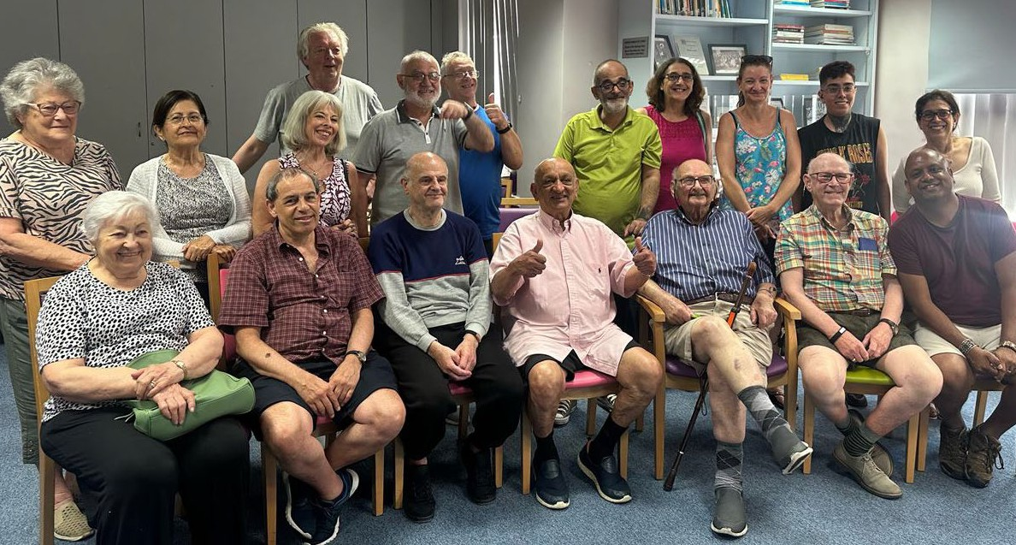

This visit to the Jewish Deaf Association from the leader of the council was part of the Leader Listens program, where the leader goes to underrepresented resident groups to hear their views and answer questions

1 Protected characteristics are the nine groups protected under the Equality Act 2010. These are age, disability, gender reassignment, marriage and civil partnership, pregnancy and maternity, race, religion or belief, sex and sexual orientation.
What people in Barnet want
Community involvement in designing policies and strategies is an important part of our journey to increase the role of residents in civic decision-making. This roadmap was produced with a range of stakeholders including residents, community groups representing diverse communities and voluntary sector partners.

Resident Engagement Programme
The engagement for designing and developing the roadmap was undertaken over two phases with residents remunerated for their participation.
Phase 1: February – August 2023
In this phase, a series of workshops and community outreach activities involved over 200 people to build insights on residents’ experiences of discrimination, their vision for a more equal Barnet and the language they felt was inclusive and appropriate for this roadmap.
What people said they wanted:
- Easier access to services
- Improved communication
- More opportunities for cross-community events
- Increased protection against discrimination
- More guidance for residents on equalities
Our residents asked us to avoid jargon where possible and to provide illustrative examples if using complex terms. They wanted a simple and visual document that was easy to understand.
Fairness, respect, representation, community, belonging and access, were all terms more commonly used by our residents than ‘EDI – Equality, Diversity and Inclusion’.
Phase 2: September – December 2023
More than 60 people were involved in more focussed work to develop and test the emerging priorities and objectives for this roadmap.
Through this phase, we learnt that residents wanted to:
- Emphasise the understanding of residents’ individuality which includes their lived experiences.
- Recognise differences not only between communities, but within communities.
- Acknowledge that services are going to need to work harder to become more accessible.
- Think about our community development offer.
- Promote respect for all and foster togetherness in addition to celebrating diversity.

Acknowledgements
Barnet Council would like to thank all groups and residents for their contributions towards the development of this roadmap. Special thanks to Barnet Together (Inclusion Barnet, Young Barnet Foundation and Volunteering Barnet), Barnet TV, The Barnet Group, Barnet Multi-Faith Forum, Burnt Oak Partnership Board, Masorti Judaism, FUSE Youth Projects, Inkluder CIC, Arts Against Knives and West Hendon Cultural Society.

A changing approach: our equalities objectives

To achieve a fairer Barnet, we recognise that we need to do some things differently and ensure that best practice becomes the normal way of working in the council. Our approach will change from typically considering inequalities as single-issue effects happening to individual residents who require help, to understanding that sometimes our residents are also impacted by structural
inequalities that require us to change the way our systems and services operate to tackle unfairness in access and outcomes.

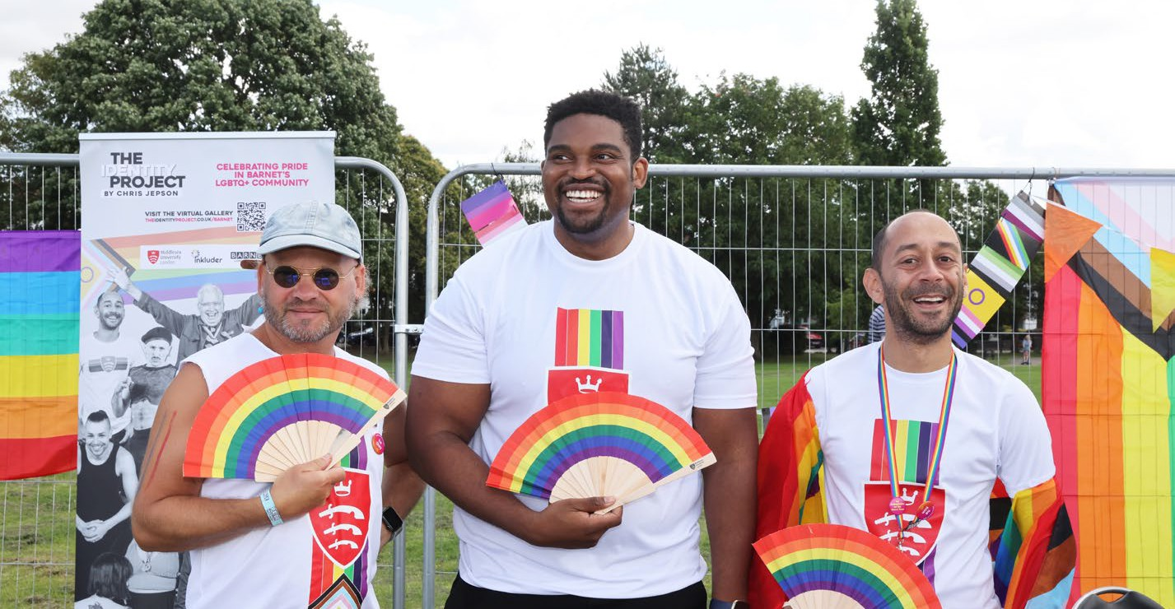
To make sure this work becomes widespread in Barnet Council, our three fairness objectives build transformative guidance into our corporate themes of ‘People, Places and
Caring for people, our places and the planet
Barnet’s first pride event was held in 2023 in Victoria Park, Finchley
Planet’ set out in ‘Our Plan for Barnet 2023-26’.
These fairness objectives also constitute our equality objectives as required by legislation.
- People: Understand the whole person
- Place: Understand and tackle local causes of inequality
- Planet: Support a just transition to net zero
Our objectives aim to ensure that we focus on equity for outcomes based on differing needs, not just equality of opportunity. In the longer-
term, they will help us to reduce the structural drivers of inequalities and improve outcomes for our residents, with a focus on tackling
the gaps between outcomes for different communities.

How we will deliver these objectives
We will embed these approaches across the council with service areas adopting these equalities objectives by adapting their core work to address inequalities, but we will also target our resources towards a few specific inequalities where we think we can make greatest impact. These priority areas are highlighted in this roadmap.

We will view people as their whole selves and not by isolated individual equalities characteristics. People are shaped by a combination of multiple factors, including not only the protected characteristics in the Equality Act but, for example, their gender
People:
understand the whole person
Caring for people, our places and the planet
identity and socio-economic background. The causes of inequality are often inter-connected and combine to create different modes of discrimination and levels of advantage or disadvantage. Recognising this provides an opportunity to better understand the lived experience of people and the issues they face.
Every person has multiple identities and characteristics. Our residents want us to recognise the differences even within
communities. No one can be fully defined by boxes of categories.
We have traditionally tackled individual problems residents have without considering the rest of the challenges they are facing.
Multi-faceted identities affect life chances, and we know issues driving inequality are complex and interlinked - so our support must be too.
Seeing people through their individual experience and respecting their multiple identities, is known as having an intersectional approach. We will not presume we know someone’s experience just by the communities or identities they belong to.

Implementing an intersectional approach
All council services will make plans to move from relating to residents just by the nature of their service request to thinking about the
whole person in the round of their experiences. This transformative work forms part of a long- term shift from relating to residents as ‘service- users’ to valuing them as respected ‘citizens’.
It will mean improving the understanding of the lived experience of our residents, particularly those experiencing multiple disadvantages, by listening and observing through working with residents (this is often called ethnographic research). It will also require better data collection to ensure that we have robust, comprehensive and more
precise information about the characteristics of our residents and service users.
Through this work we want to also build the conditions for cohesion in the community. Key to this is supporting new communities who are most at risk of harm. This includes new residents seeking sanctuary, as well as British citizens with ties to Barnet, returning from conflict zones.
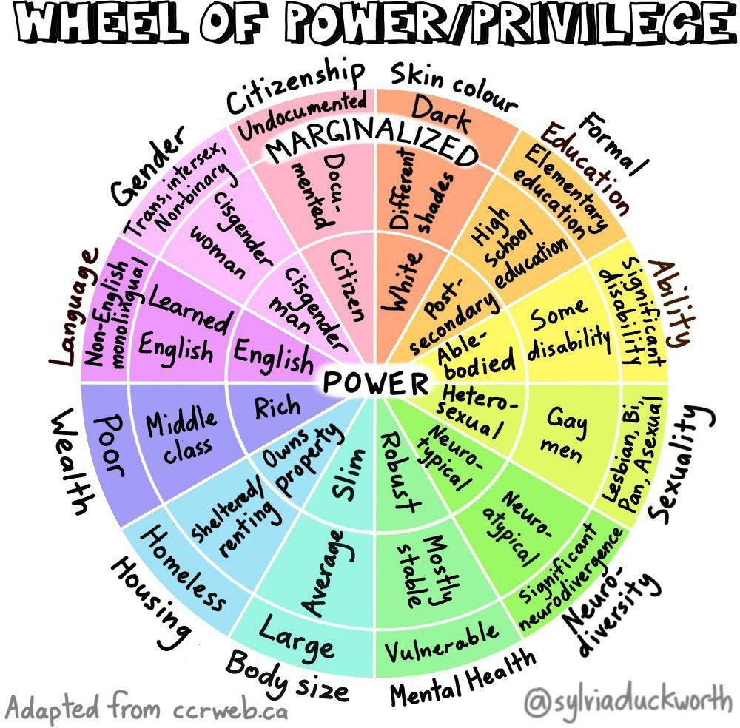
This wheel shows how different parts of someone’s identity affect their power and privilege. These different characteristics overlap
to influence how people live their lives

Adult Social Care

In Adult Social Care in Barnet, we consider someone as an individual, their strengths, interests and what is important to them, so that they feel empowered and in control.
For example, we recently worked with Barnet resident Hassan and his family who are originally from Syria. After being diagnosed with dementia, Hassan exhibited some physical behaviours towards family members who were his main carers. Current affairs, including the recent conflict in the Middle East, exacerbated Hassan’s anxiety and past trauma relating to leaving his homeland. This had a negative impact on Hassan’s behaviour towards his family. Hassan and his family were scared to be separated and did not want any social care involvement including from care agencies.
Hassan’s social worker spent time getting to know Hassan and his family to find the right support for Hassan whilst keeping him and his loved ones safe. Whilst working with Hassan and his family, his social worker learned that they all wanted Hassan to remain at home. By involving Hassan’s family to better understand Hassan’s life experience and how it affects his behaviour now, his social worker was able to build trust with Hassan and with his family which helped when explaining what the options were, and what would happen next.
Hassan’s social worker facilitated multi-agency work with health professionals, care agencies and community organisations to honour Hassan and his family’s wishes to remain together. This included careful risk assessment with Hassan’s family and professionals so that his family understood the impact of Hassan’s medication on his behaviour. Hassan’s family was able to continue as his main carers while trusted agency care workers joined Hassan for walks in his local area.
Hassan’s daughter was grateful for the way the social worker approached working with Hassan and the effort that was made to build trust, understand Hassan as a person and prioritise what was most important to him.
Our priorities: understand the whole person
Our two priority areas for this roadmap will be improving outcomes for people with disabilities and those with care experience.

Disability rights, voice and outcomes (including removing barriers to inclusion)
The ‘Residents’ Perception Survey 2021/22’ showed that disabled residents are significantly less likely to be satisfied across a number of key indicators compared to residents without a disability. To investigate
these findings in-depth, the Tackling the Gaps Group commissioned Habitus, a specialised ethnographic research company, to conduct a study to understand the lived experiences
of disabled residents. The project set out to address the following objectives:
- To understand the lived experiences of disabled residents (and to some extent their families and carers) in engaging or accessing council and community services.
- To explore how different protected characteristics and intersectionality shape disabled participants’ lived experiences in engaging in community life.

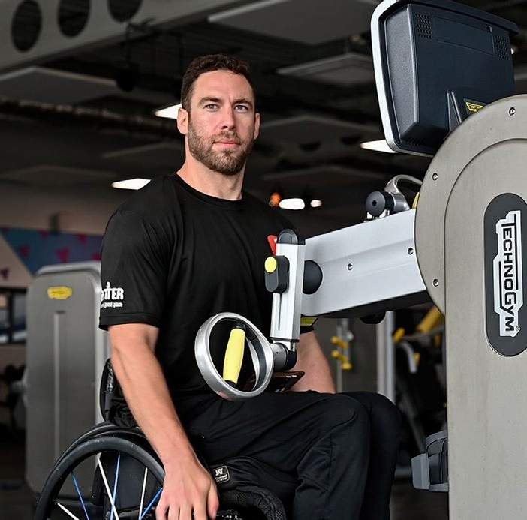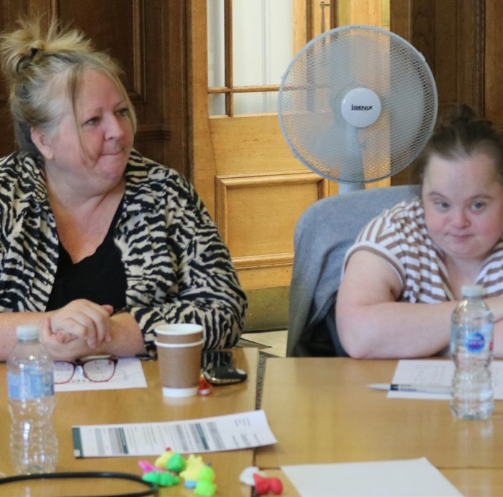
A wheelchair user exercises in a gym
As part of the council’s People’s Voice engagement community, the council runs events like this learning disability coffee and bingo morning

  - To identify barriers to participation in council and community services.

Caring for people, our places and the planet
Four recommendations were shaped by the disabled residents, parents, and carers who took part in the study:
  - Understanding how residents identify and want to be identified is key in meaningfully engaging with them.
  - Consider how disabled residents access information and find different modes of making this accessible.
  - Community matters – working with voluntary sector organisations can help disabled residents engage meaningfully in community life.
  - Create opportunities to enable disabled residents to engage in community life and civic participation in different ways.
We will respond to delivering these recommendations to improve outcomes for residents with disabilities through the actions planned for this roadmap.
We use the social model of disability, which recognises that people are disabled by barriers
in society, not by impairment or difference, and we will extend and embed this approach across the whole council. We recognise that when anything is designed to be accessible for disabled people, it is also designed to benefit others.

Care experience
At its meeting in January 2024, the council recognised that care experienced people face significant barriers that impact them
throughout their lives and that they often face discrimination and stigma across housing, health, education, relationships, employment and in the criminal justice system. They
may also encounter inconsistent support in different geographical areas.
The council adopted the Care Leavers Covenant and agreed to lobby government for a change in the law to allow care experience to become a protected characteristic under the Equality Act and other legislation. As a priority in this roadmap, we will build on this decision by considering the needs of people with care experience in all aspects of the council’s work. We will proactively seek out and listen to the voices of care experienced people when taking decisions and developing new policies.
Case study: care-leaver support

This young care experienced person received a diagnosis of autism spectrum disorder (ASD) and in a letter to the steering group of the council’s autism hub, they reflected on the diverse experiences of individuals with ASD.
“One of my many goals is to help, and call people into understanding African-Caribbean (among additional ethnic minorities) children and young adults with ASD.
“I alone, of course, cannot speak for an entire community of people with ASD as every individual (by word of principle) have to be taken on the merit of their own individual experiences, as every person experiences, ASD differently, and everyone’s relationship with their condition will vary from person to person.
“ASD is a broad spectrum, and there are a lot of subtle nuances that myself with ASD (and neurodivergent, young adults and children with my condition) and neurotypicals may not understand, or may not know, or may not be ready to engage with. Exercising discretion, grace, compassion and empathy is important to help those in need of our assistance,
as well as relying on each other to make this process evolve and grow, organically and genuinely.
“My purpose in life is to constantly improve and ultimately if I desire change, I have to continually improve to be the change I wish to see with the Black community, the Borough of Barnet and society as a whole.
“I also hope to help evolve and develop the narrative around Black children with ASD by sharing my experiences and what has helped me to be where I am at today.”

Caring for people, our places and the planet

Place:
understand and tackle local causes of inequality

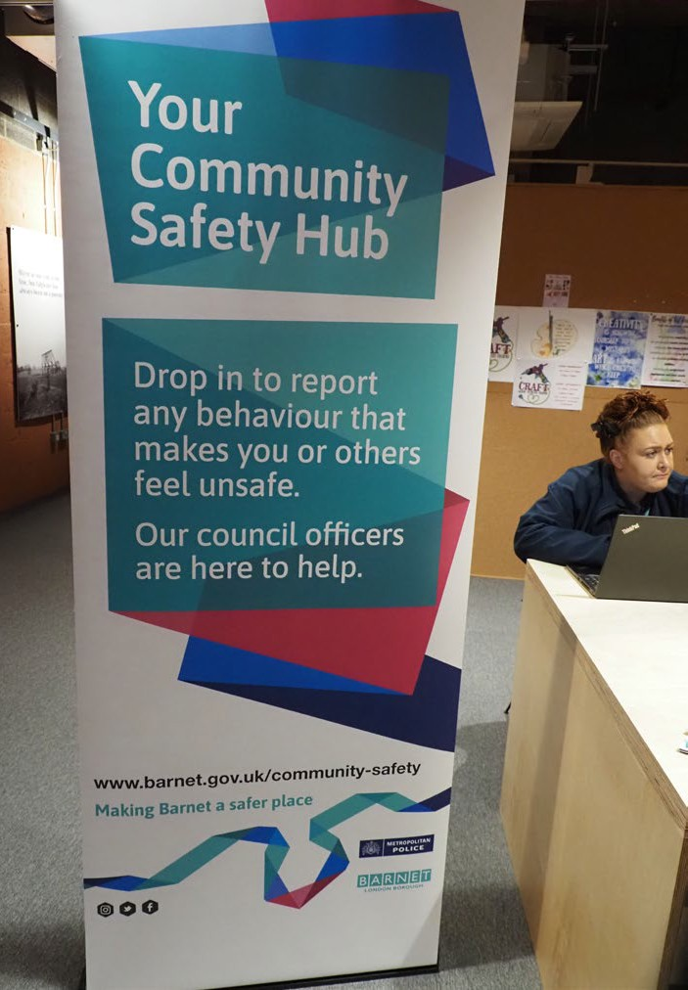

Where you live can unfairly impact your life chances in Barnet. For a long time, we have focused on fixing individual problems that residents come to us with rather than tackling the structural root causes that are
driving inequality. The ‘State of the Borough Report 2023’ shows us that many avoidable inequalities are determined by where people live in the borough.
Place-based drivers of inequality are the conditions at a neighbourhood level that influence our opportunities for good health and wellbeing. They influence how we behave and how we think and feel, all of which impacts our life chances. Some residents face discrimination and disadvantage with poorer access to infrastructure and services, such
as libraries, public transport, parks and green spaces.

Feeling safe
Perceptions of safety in the borough also vary, with people experiencing racism, antisemitism, islamophobia or other forms of hate crime. This is heightened by incidents and world events, such as the present-day conflict in Israel and Gaza. Despite this, our ‘Adult Resident Perception Survey (2023/24)’ show that large majority of residents (85%) agree that their local area is a place where people from different backgrounds get on
Barnet’s Community Safety Hubs are safe places where people can anonymously report behaviour that makes them or others feel unsafe
well together. This is above the London (83%) average. Collaborating with the police and partners in our neighbourhoods, we will work together with communities that experience hate crime, instilling a feeling of safety. This includes sharing data and information, as well as understanding different communities’ experiences of safety. For example, residents’ experiences of going out after dark, and how
that is impacted by their faith, gender or other factors.

Working locally, together
We will improve our understanding of the structural, place-based drivers of inequalities. We will use place-based systems that work with local communities and public, voluntary and community sector partners to agree shared priorities for local neighbourhoods experiencing the greatest inequalities.
Based on employment, education, health and disability and housing status, the 2021 Census showed that the highest proportion of households experiencing at least one dimension of deprivation are found in Burnt Oak and Watling Park (66%), Brent Cross and
Staples Corner (64%), Grahame Park (62%), Mill Hill Broadway (60%), West Hendon (58%) and Hendon Central (58%). We will take action on the key drivers of health inequalities bespoke to specific local areas, with the aim of reducing inequalities.
People have told us that they want us to think about the role of community development
in our fairness roadmap. We will review our community investment to support the
development of local and grassroots capability and capacity which can maximise the benefits of our place-based approaches.

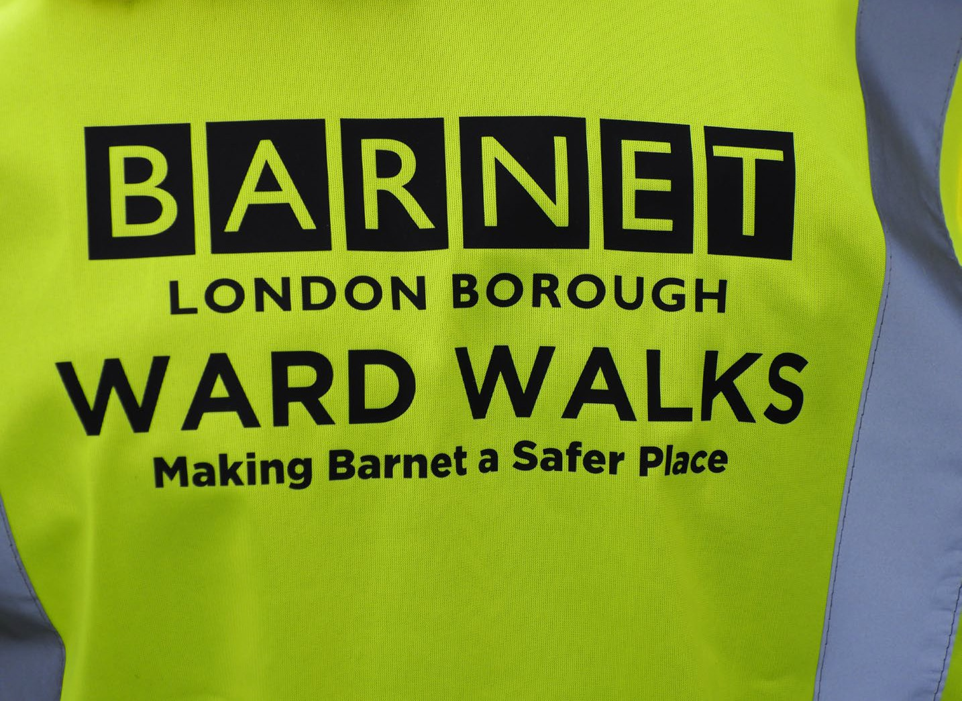

Ward Walks are an initiative where local councillors and council staff visit boroughs to investigate specific community safety issues that have been raised by the local community

Case study: Burnt Oak Partnership Board
Through working with the community at Burnt Oak, we recognise the need to remove barriers to participating and engaging with our development of the area. To broaden the council’s reach into the community, Burnt Oak Partnership Board was established in 2022. It enables residents to share their views on Burnt Oak development proposals and shape how we develop the place, its public spaces and buildings (‘placemaking’). The view is to build a long-term basis for community participation and establish regular flow of communication between the council and the community. The aim of the board is to bring together key stakeholders in Burnt Oak including residents, councillors, community groups and local businesses to work together to monitor, review and support the Burnt Oak place vision.
The board creates a space where the council can consult with communities about local development and placemaking in real-time, seeking feedback on issues and ideas on
a more regular basis than would otherwise be possible. This is whilst also training and upskilling local people in matters like architectural design and planning policy to help facilitate meaningful engagement. In building strong relationships with local stakeholders, the board sets the foundations for more ambitious participation opportunities including building capacity for co-production and community led initiatives, nurturing civic leadership.

Our priorities: understand and tackle local causes of inequality
Our two priority areas for this roadmap will be housing and homelessness, and health inequalities.

Housing and Homelessness

Caring for people, our places and the planet

Accessibility of housing:
People are living longer and the proportion of older people in our population is growing.
In 2021, 56,100 Barnet residents were aged over 65, an increase of 18% over the previous ten years. 49,679 residents self-identified as having a disability that limited their day-to- day activities. Improving the independent living choices of older people, those with limited mobility and those with learning difficulties and autism is important for their health and wellbeing and to enable them to remain more connected to their communities. We will ensure that older people and those with disabilities have a better choice of accommodation to suit their changing needs.
We also recognise that having access to culturally appropriate housing is a critical part of creating diverse and equitable communities.
As part of our housing programmes, we will consider the unique needs, preferences and values of people from different cultural backgrounds to ensure that everyone
has fair access to suitable and affordable accommodation. As well as particular housing design features, this includes factors such
as household size, multi-generational living and accessibility requirements. The key will be to provide a broad range of housing that is flexible to meet different cultural and faith- based needs. We will engage members from diverse backgrounds in the planning and
development stages to ensure that their voices are heard and their needs are addressed.

Preventing homelessness:
With rents in the private rented sector at record levels and rising at the highest rate in decades, people have reached the limits of what they can afford to pay and the risks of homelessness have increased. There is clear disproportionality for specific groups in relation to homelessness.
In the most recent sharp rise in homelessness, people most at risk were those who were renting in the private rented sector. People who are renting are living in increasingly precarious situations, at risk from rent rises and cost of living pressures. We will consider how we support residents who are renting to avoid risks of becoming homeless.
The success of early intervention and prevention support is limited by persisting barriers to accessing services, which can directly cause housing issues to grow. Digital barriers, language barriers and mobility issues all disproportionately impact certain groups. Disproportionality studies undertaken show an over-representation of Black people and those with disabilities (particularly mental health) approaching Barnet Homes as homeless. We will improve the quality of our support and strengthen targeted interventions to prevent homelessness as part of our Homeless and Rough Sleeping Strategy.

Action on the social determinants of health in neighbourhoods
Health inequalities in Barnet vary across the borough and many of these are avoidable health gaps. There are marked differences in people’s life expectancy across Barnet. The
difference between people living in the most and least deprived areas of the borough is 5.7 years for females and 6.7 years for males.
Wherever we work in neighbourhoods experiencing disadvantage, we will focus our work on supporting the building blocks of health, otherwise known as the social (or wider) determinants of health – which are
one of the main reasons for the differences in people’s health, with other reasons including access to healthcare. We will take a place- tailored approach to address the causes of this inequality and improve community health outcomes.
We will focus on the building blocks of good jobs that provide fair pay and good working conditions:
- Increasing access to high quality local environments
- Access to the right shops; and support with housing, skills, education, food security and digital skills.
These will be supplemented by a focus on bringing people together to increase social connection and create stronger communities to reduce loneliness and isolation, and on increasing the participation of local people in local projects and decision-making. These can all contribute to the building blocks of health and help to reduce health inequalities in the borough.
We will also ensure that all policies and strategies include specific actions on tackling health inequalities through action across
the social determinants of health, such as by creating good housing, employment opportunities and active travel links.

more sustainable borough and tackle climate change, we are committed to doing all that we can to prevent inequalities that may result from our actions. In delivering our sustainability action plan, we recognise that the journey to net zero needs to not only deliver emission reductions but also do this in a way that does not negatively impact
As we go further and faster to become a New, green opportunities
our residents, including those with protected characteristics.
We will develop an equitable approach on access to green opportunities, such as EV charging opportunities and solar panels on domestic properties, and use case studies or personas to show what transition to becoming more sustainable means for different parts of the community.
We will think through how the urgent transition to net zero can happen whilst avoiding creating new gaps or widening existing ones. We will review impacts to ensure that the costs of climate policies do not fall unequally on different groups of people.
Our revised Transport Strategy and subsequent action plan will consider how transport works as a barrier to opportunities and incorporate supporting a fair transition in its vision and approach.
In attracting sustainable businesses and investment, we will work with our partners to address the existing inequalities in the green workforce, which is male dominated, with
a lower proportion of workers from Black, Asian and Minority Ethnic backgrounds in comparison with all sectors in London.
We will work with our regional and subregional partners to do all we can to protect residents from ‘greenflation’, where companies cost measures for tackling climate change out of the reach of the communities experiencing the worst of the impact.
In our plans for the council to become net zero by 2030, we will work with our suppliers to ensure net zero responsibilities are owned by suppliers and considered in our procurements.
Planet:
support a just transition to net zero
Caring for people, our places and the planet
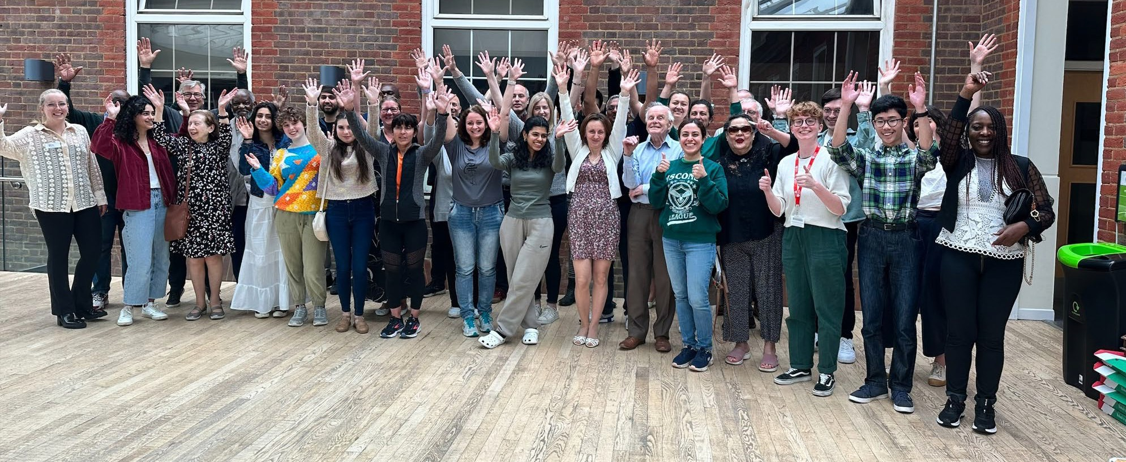
Barnet’s Citizens’ Assembly for Climate Change asked the community how the borough could be made more sustainable. These insights were used to shape the council’s sustainability work with discussions held at Middlesex University
Caring for people, our places and the planet

Our core work to tackle inequalities programme

All our services work to tackle inequalities and address disadvantage through their own strategies and policies. These often focus on taking a preventative and early intervention approach to provide effective support to those at risk of poor outcomes.
This core work will adapt to respond to our new equalities objectives. In addition, we will continue to celebrate the diversity of our borough and foster community cohesion by encouraging mutual understanding between communities, including by supporting and organising events and celebrations. We will challenge discrimination and tackle harassment and hate crime in all its forms.

Core work to tackle inequalities programme

Children and young people
  - Narrowing gaps in educational achievement
  - Tackling the disproportionate exclusion of Black students from school
  - Supporting children and young people with special educational needs and disabilities to achieve good attendance
  - Ensuring the effective use of social work tools in considering intersectionality
  - Building on existing good practice, ensure effective involvement and coproduction with children, parents and carers

Adults and social care
  - Ensuring targeted and proactive engagement so that participation and coproduction in adult social care is representative and diverse and supporting more inclusive provision
  - Improving advocacy and support for groups more at risk of experiencing social inequalities
  - Improving the experience of adult social care services for autistic adults through the Autism Champions practitioner network and coproduction
- Ensuring culturally sensitive, strength-based practice across adult social care through cultural competence training and quality assurance measures
- Supporting Age Friendly Barnet to enhance the social inclusion and wellbeing of older residents through an intersectional lens

Public Health
- Tackling mental health issues for Black men and boys by working with the Barnet Borough Partnership and the North London Mental Health Partnership Mental Health Inequalities
- Reducing the risk of or impact of cardiovascular disease for specific population groups working with the Barnet Borough Partnership and community groups
- Reducing childhood and adult obesity by supporting weight management, a healthy food environment and physical activity opportunities in particular population groups
- Reducing suicides by targeting specific population groups with higher than average levels

Towards a Fair Barnet 2024-2030
22
Our roadmap to create a more equal Barnet, where local people can belong
Caring for people, our places and the planet

Homelessness
  - Focussing on tackling disproportionality in housing and homelessness through our Housing, Homeless and Rough Sleeping Strategy

Refugees and asylum-seekers
  - Supporting refugees and asylum-seekers and becoming a ‘Borough of Sanctuary’

Employment and skills
  - Creating employment opportunities for all through BOOST and other local employment and skills initiatives and
offering carved employment opportunities in the council for people with learning disabilities

Crime, community safety and enforcement
  - Through the Community Safety Partnership, working with Police colleagues to understand and address any disproportionality in policing in Barnet,
focusing on use of stop and search powers.
  - Working with partners to tackle violence against women and girls, including trialling the provision of Safe Havens in town centre and neighbourhood locations to support women and girls feeling safer during evening and night-time hours
  - In light of the present conflict in Israel and Gaza, we will promote tolerance and fight any forms of antisemitism and islamophobia in the borough. This will ensure we continue to be a community which gets along well together.
  - Improving data collection across all council enforcement activities to assess disproportionality

Environment
  - Ensuring regeneration and development adopts design principles that promotes accessibility and inclusion through its location, layout and design
  - Supporting the improvement of air quality and tackling inequalities through BarnetNET Zero
  - Ensuring a just transition so that the benefits of green policies are shared widely and no one is left behind
  - Retrofitting council homes through grant funded programmes which prioritise low- income households and help reduce fuel poverty, phase out high carbon fossil fuel heating and deliver progress towards Barnet’s commitment to be net zero as a borough by 2042.
  - Understanding adaptation to mitigate and reduce inequalities of climate change impacts
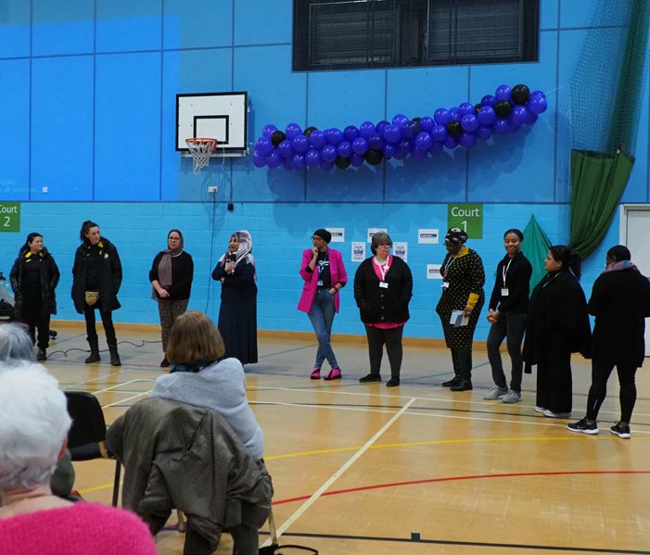
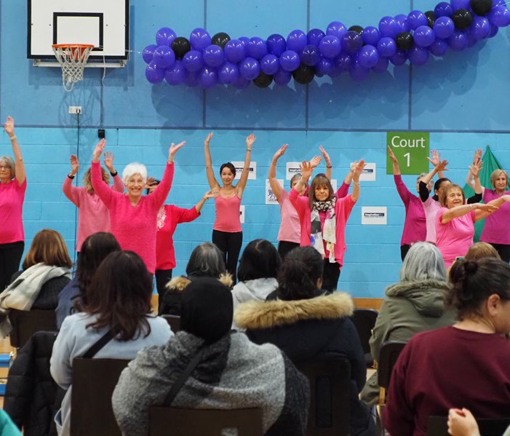

International Women’s Day 2024 at Burnt Oak Leisure Centre
International Women’s Day 2023 at Burnt Oak Leisure Centre

Towards a Fair Barnet 2024-2030
23
Our roadmap to create a more equal Barnet, where local people can belong
Caring for people, our places and the planet

The council collaborates with the Met police to look after communities and build trust to keep people safe

    - Reviewing winter maintenance arrangements and operational methodologies to identify opportunities to expand service reach fairly
    - Exploring opportunities to align the principles of the council’s food waste plan and the introduction of a separate food waste collection service to support sustainable consumption and a healthy food environment
    - Providing enhanced recycling collection services (including separate food waste collection) to flats and properties in multiple occupation
    - Improving demographic data capture for users of front-line environmental services

Access to services
    - Making our digital services and website content simpler, easier and faster for residents to use
    - Advancing digital literacy through targeted skill support, ensuring equitable access
to devices and connectivity for residents seeking to enhance their digital capabilities
    - Ensuring information, services and support are accessible and meaningful
    - Providing support for residents that considers their whole needs, including those with multiple and cross-cutting issues
- Reducing barriers to accessing goods and resources, for example through concessionary pricing models
- Improving our equalities, diversity and inclusion data collection relating to the council’s corporate complaints process

Democratic, civic and community participation
- Ensuring effective community participation, engagement and co-production and improving our use of community intelligence in design, strategy and policy- making
- Developing our communications, events and other activities to better promote community cohesion and celebrate diversity
- Reviewing how our commissioning, investments, assets, grants and other activities can be used to tackle inequalities and disproportionality
- Encouraging participation in elections and the democratic process, including amongst those groups that are less likely to be registered to vote
- Improving our monitoring and reporting of inequalities, including through future State of the Borough reports
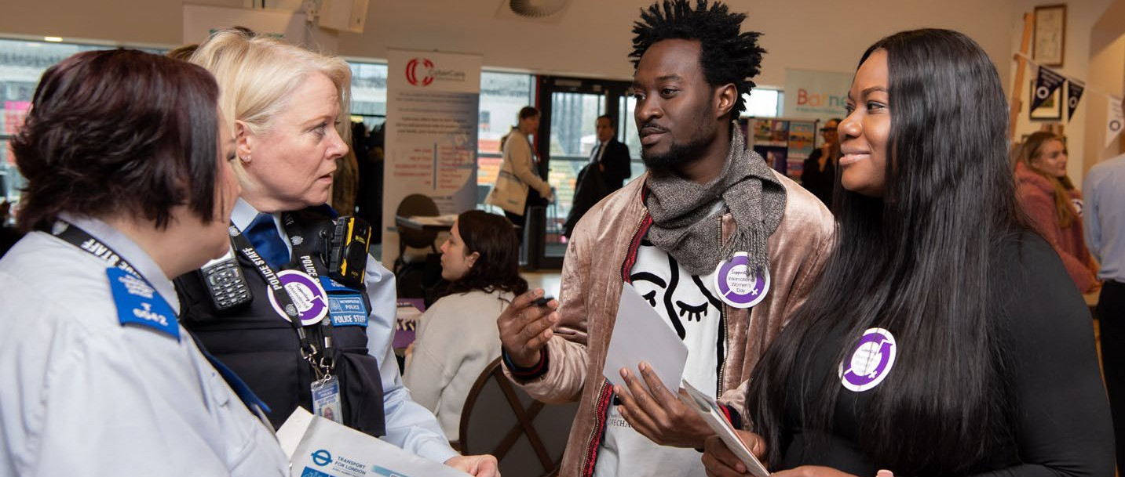

Towards a Fair Barnet 2024-2030
24
Our roadmap to create a more equal Barnet, where local people can belong
Caring for people, our places and the planet

In partnership
We cannot tackle inequalities on our own and will work in partnership with others. For example, this includes working with health agencies to reduce health inequalities and improve healthy life expectancy through the Barnet Health and Wellbeing Strategy and the Metropolitan Police and other partners to deliver the aims of the Barnet Community Safety Strategy.
As an example, we will work with community safety partners to support measures being undertaken by the Mayor of London and

Metropolitan Police to work with communities to improve trust and confidence in the police. This includes measures to address community concerns about the disproportionality in the use of certain police powers affecting Black Londoners, who are more than three times more likely to be stopped and searched by police than White Londoners. New data will be collected from Black communities on their lived experiences and interaction with police officers to improve existing local community oversight of policing.

This photography exhibition commemorating the Windrush generation was organised in partnership with Barnet Multi Faith Forum

How we will know we are having impact

We will develop an action plan to support the delivery of our work on our equalities objectives and priorities. Progress against the actions in the plan will be tracked and
scrutinised by our Tackling the Gaps Group and reported to our senior Council Management Team. We will report publicly on progress through our annual equalities report.
To ensure transparency and increase visibility, we will develop an online hub capturing the totality of what we are doing to address inequalities bringing this together in one place. This will include information on progress in
delivering this roadmap, details of our core equalities work and the effectiveness of our interventions and published equalities impact assessments.
We will strengthen our approach to equalities impact assessments to ensure that the effect of our decisions, policies and strategies on different sections of the community are properly considered and publish these on our new online equalities hub. We will review how our equalities impact assessments consider intersectional issues.
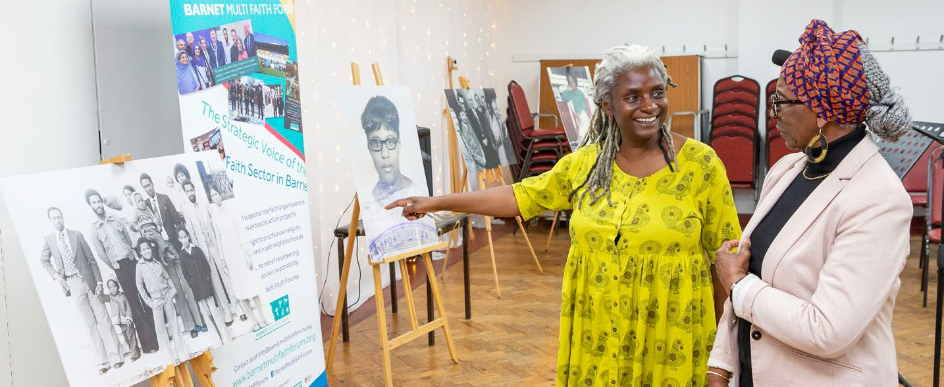

Towards a Fair Barnet 2024-2030
25
Our roadmap to create a more equal Barnet, where local people can belong



Caring for people, our places and the planet

Caring for people, our places and the planet

www.barnet.gov.uk

